GitHub URL:
https://github.com/isa99sv/csd-340#

HTML Checker Failed:
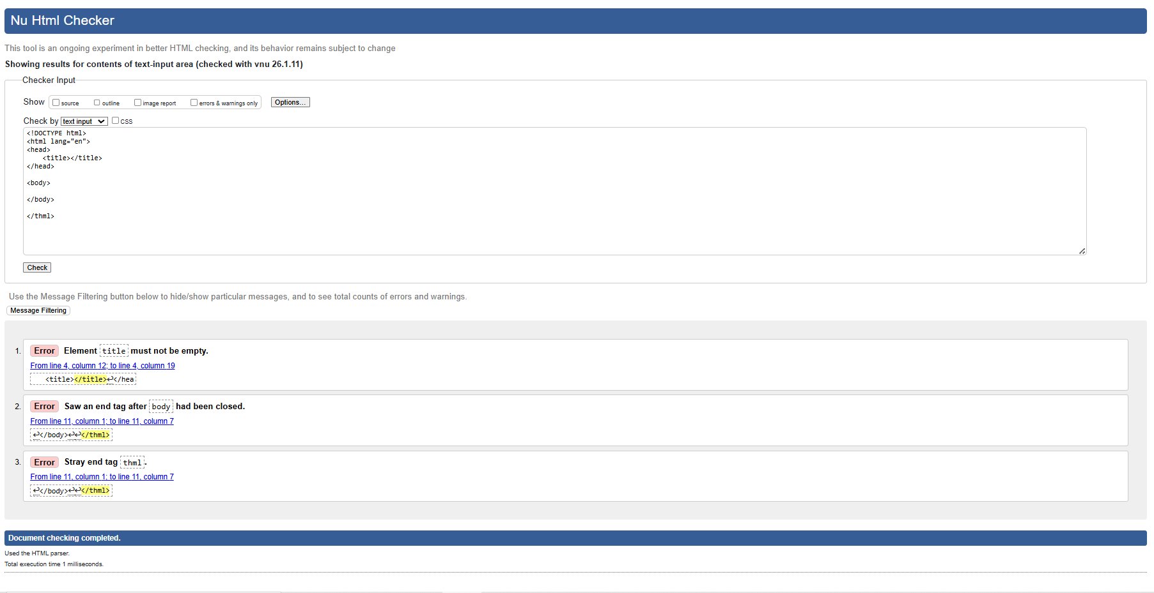

HTML Checker Passed:
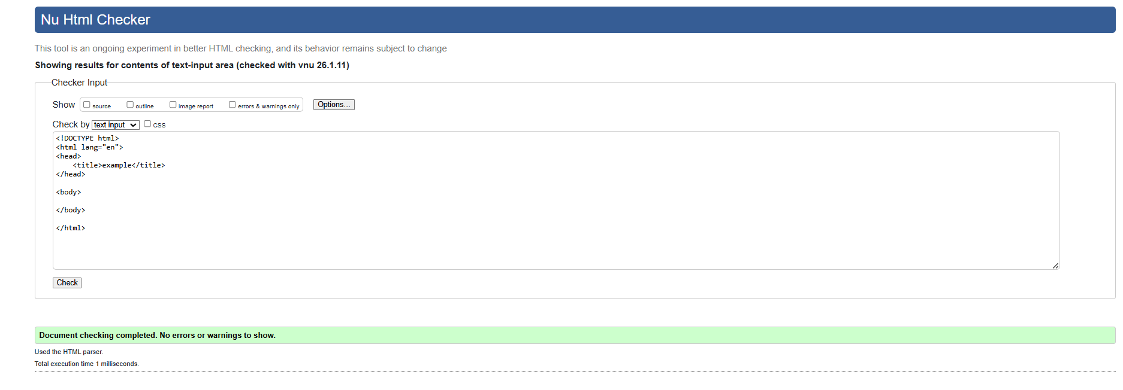
HTML Checker Updated Code:
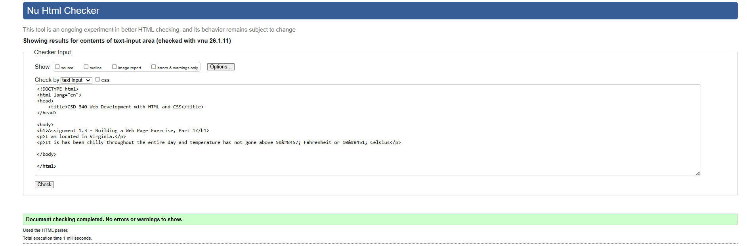

Browser Update:
